W-16
YEAR 12 PHYSICS
ASSIGNMENT 7 - STANDARD MODEL
Name: Mark: 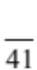

1. The Milky Way galaxy (our galaxy) and the Andromeda galaxy are approximately 250 000 light years apart, and they are approaching each other at a rate of 110 kms⁻¹. Scientists know this because of the blue-shift of light coming from the Andromeda galaxy.

Read the following statements and circle ‘True’ or ‘False’. (3 marks)

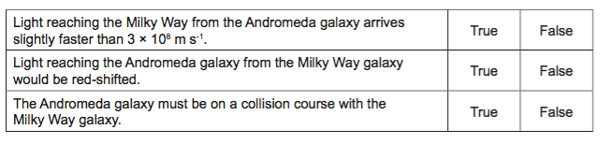

2. The recession speed of a Cepheid variable star was determined as 28 800 kms⁻¹ moving away from the Earth. Assume that the star’s motion was due only to the expansion of space.

The star’s recession speed v_{rec} is linked to Hubble’s constant, H₀, by the relationship:
v_{rec} = H₀ × d
where d is the distance of the star from the observer.

(a) Using appropriate assumptions and Hubble’s constant of 1.86 × 10⁻⁵ kms⁻¹light-year⁻¹, determine the star’s distance from an observer on the Earth. Include units in your answer, and show all workings. (3 marks)

(b) Estimate the star’s current distance from the Earth (in light-years), taking account of the distance that the star travelled while the light from the star travelled to Earth.
Show all assumptions and workings. (5 marks)

(c) Estimate how long it would take for light to travel from the current position of the star to an observer on Earth. Explain why this must be an estimate. (2 marks)

3. An exotic hadron, initially seen over 40 years ago, has recently been confirmed at the European Organization for Nuclear Research (CERN). The Z(4430) particle consists of four quarks: a charm, an anti-charm, a down, and an anti-up.

Use the following table to show the calculation required to determine the charge of the
Z (4430) particle. (2 marks)

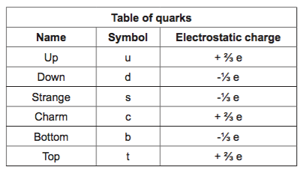

4. A space probe travels along a line from the Earth to Uranus at a constant speed of 0.95c relative to the solar system. Just as it reaches midway between the two planets, it sends laser beams out to the Earth and Uranus at the same time. At what speed do the laser beams approach the Earth and Uranus, respectively? (3 marks)

Speed of laser beam approaching the Earth:

Speed of laser beam approaching Uranus:

To an observer on Uranus, will the light from the space probe appear red shifted, or blue shifted? Circle the correct answer.

red shifted blue shifted

5. Describe briefly the relationship between the mass and energy of an accelerating object as its speed approaches, but cannot exceed, the speed of light in vacuum, c. (3 marks)

6. Hubble’s law can be used to estimate the maximum size of the observable Universe. The graph below indicates the relationship between recessional speed of a star (or galaxy) and the distance to that star (or galaxy).

Distances are given in megaparsecs (Mpc) where 1 Mpc = 3.26 light years.

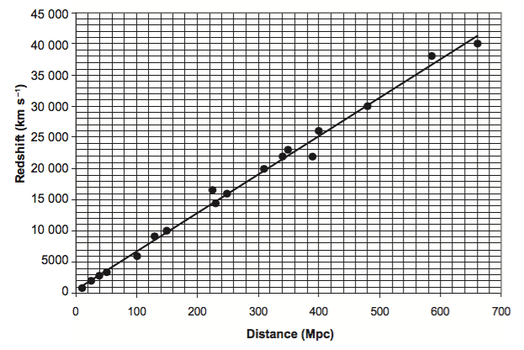

(a) The vertical axis is labelled ‘redshift’ with units for velocity (kms⁻¹). Explain briefly the relationship between redshift and the speed of the object. (2 marks)

(b) Use the gradient of the graph to extrapolate a value for the maximum distance, in Mpc, for a galaxy to be observed from the Earth. Show all workings. (3 marks)

7. A distant star is seen by an astronomer using a powerful telescope to be travelling toward the Earth with a velocity of 0.1c.

(a) At what velocity does the light reach the telescope? (1 mark)

(b) What is it about the starlight’s spectrum that tells the astronomer that the star is approaching? Explain your answer. (2 marks)

8.
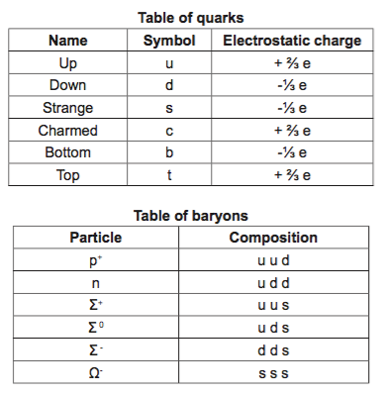
(a) Use the information in the above tables to explain why the electrostatic charge on the Σ⁰ particle is neutral. (2 marks)

(b) It is possible for another baryonic particle to exist in nature with a positive electrostatic charge equal to that of the proton. What would its quark composition be, given that this particle contains two up quarks and is not a proton? (1 mark)

9. A geostationary satellite orbits the Earth at an altitude of 35 000 km. It travels at a speed of approximately 3000 ms⁻¹.

Relativistic effects may cause a clock on board the satellite to run a little slower or a little faster than the same clock on the surface of the Earth. Considering the factors that may lead to relativistic effects, complete the table below. (3 marks)

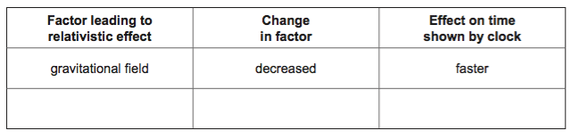

10. The figure below shows three simplified absorption spectra for ionised calcium. Many of the absorption lines and the background colour have been removed. In all three spectra the same two absorption lines, ‘a’ and ‘b’, are shown. The top spectrum is an example of a spectrum recorded in a laboratory on Earth; the lower two have been recorded from two different galaxies.

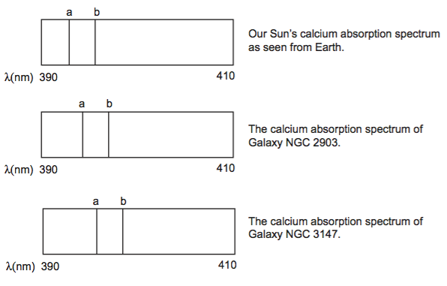
(a) Explain why absorption spectra appear as dark lines on an otherwise continuous electromagnetic spectrum. (3 marks)

(b) Which galaxy is further away from Earth? Justify your answer. (3 marks)

